ROUGH DRAFT

Title:

Propensity-weighted prognostic associations of hypercapnia by Arterial and Venous Blood Gas: A retrospective, multicenter health records study

Authors:

Anila Mehta MD¹, Jeanette P. Brown MD, PhD², Ramkiran Gouripeddi MBBS MSc³, Ithan Peltan⁴, Brian W. Locke MD, MSc⁴

¹University of Utah Internal Medicine Residency
² Division of Pulmonary, Critical Care, and Occupational Pulmonary Medicine, University of Utah
³Department of Biomedical Informatics, University of Utah
⁴Department of Pulmonary and Critical Care, Intermountain Medical Center.

Funding:

Conflicts of Interest:

B.W.L. equity interest with Mountain Biometrics, a medical AI startup.

Author Contributions:

Data/Code Availability Statements:
Statistical code is available at https://github.com/reblocke/abg-vbg-project
Individual patient data is from TriNetX and is accessed under a data use agreement and cannot be shared.

Abstract: [ ] TODO last

Background:

Methods:

Results:

Conclusions:

Introduction:

Hypercapnia results from lungs’ inability to adequately remove carbon dioxide from the bloodstream, leading to its accumulation. Arterial blood gases (ABGs) are the standard method for assessing ventilation and diagnosing hypercapnic respiratory failure but are painful, technically difficult and carry procedural risks. ¹
Because venous sampling is routine, VBGs may offer a simpler and more patient-centered alternative to ABGs, though their value hinges on whether they carry comparable diagnostic and prognostic information. On ABG, hypercapnia is defined as greater than 45 mmHg while on VBG, hypercapnia is typically defined as greater than 50 mmHg. VBGs are increasingly being used as a screening tool for hypercapnia due to ease of collection and reduced risk, though they are less precise in measuring arterial pCO₂ compared with ABGs.
Despite their growing clinical use, few studies have directly compared venous and arterial blood gases in a diagnosis of hypercapnic respiratory failure, and current billing and device qualification standards do not recognize VBG measurements as sufficient diagnostic evidence. Prior investigations have largely focused on analytic agreement between ABG and VBG pCO₂ values, with mixed results. In a study by Davies et. al, hospitalized patients with known or suspected hypercapnic respiratory failure underwent near-simultaneous ABG and VBG testing, demonstrating close agreement in arterial pCO₂ values and calculated values derived from VBGs, supporting the use of VBGs in monitoring hypercapnia.² Similarly, Lacy et. al analyzed a prospective study which found VBG to have 100% sensitivity in identifying hypercapnia in those with respiratory failure due to COPD exacerbation, pneumonia, heart failure and asthma using PvCO₂ greater than 45 mmHg.¹ Ak et. al published an additional prospective study in COPD patients in acute exacerbation that found VBG to identify hypercapnia in 100%. ³ In contrast, McKeever observed wide variability between arterial and venous CO₂ levels in COPD patients with acute exacerbations, highlighting the limitations of analytic precision.⁴ While these studies inform analytic interchangeability, analytic concordance alone does not establish clinical utility. The key unanswered question is whether hypercapnia identified on VBG can predict patient-centered outcomes such as ventilatory support or deterioration as well as hypercapnia on an ABG. If venous hypercapnia carries similar prognostic weight, analytic imperfections may be acceptable and VBGs could serve as sufficient evidence of hypercapnic respiratory failure.
We therefore examined whether hypercapnia by ABG and VBG predicts clinical outcomes in similar ways. After weighting for the propensity to receive each test, we compared their associations with diagnosis code for hypercapnic respiratory failure, receipt of invasive mechanical ventilation, receipt of non-invasive ventilation (NIV), and 60-day any-cause mortality. We hypothesized that venous and arterial hypercapnia would demonstrate similar associations with clinical outcomes, supporting VBGs as a viable alternative to demonstrate hypercapnia when ABGs are not performed.

Methods:

We conducted a multicenter retrospective cohort study using de-identified patent data from the 2022 TriNetX research network (TriNetX, LLC. Cambridge, MA), which aggregates electronic health record data from participating health systems. At the time of data requisition, the network included 76 medical centers across the US serving roughly 115 million patients. The University of Utah Institutional Review Board reviewed the study protocol and determined the project met criteria for exemption (IRB #00184622).

Study Population
Adult patients (≥ 18 years) were eligible if they had evidence suggesting possible hypercapnia during an emergency department or inpatient encounter between January 1 and December 31, 2022. We operationalized “reasonable suspicion for hypercapnia” using prespecified codes and laboratory indicators (e-Appendix 4), including (1) an arterial or venous blood gas obtained on the first hospital day; (2) diagnostic codes for any respiratory failure, (3) a diagnosis code for a condition known to cause hypercapnic respiratory failure, (4) severe obesity (body mass index of 40 kg/m² or higher); or (5) procedure codes for invasive or non-invasive ventilatory support. Ambulatory encounters were excluded. Only the first eligible encounter during the study period was used for each patient. To exclude institutions submitting only partial data to TriNetX, patients with no values any type of information (such as vital signs, labs, or diagnosis codes) were excluded. All definitions, including LOINC, ICD-10, and CPT/PCS codes used to identify eligible encounters, are provided in e-Appendix 4.

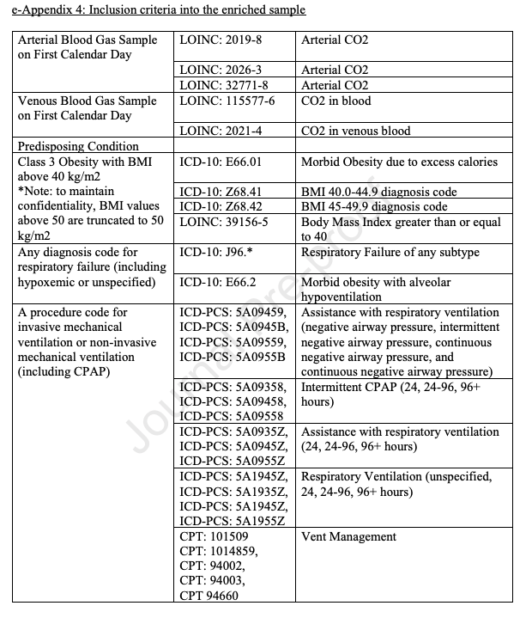

Exposure

Arterial and Venous blood gas measurements from the calendar day of the encounter start (day 0) were used to define the exposure. Arterial samples were identified using LOINC codes 2019-8, 2026-3, and 32771-8 ); venous samples were identified using LOINC codes 115577-6 and 2021-4. CO₂ was modeled in two forms. First, as a categorical variable: low (PaCO₂ <35 mmHg; PvCO₂ <40 mmHg), normal (PaCO₂ 35–45 mmHg; PvCO₂ 40–50 mmHg), and high (PaCO₂ ≥45 mmHg; PvCO₂ ≥50 mmHg). Second, we modeled CO2 as a continuous variable using restricted cubic splines with 4 knots, allowing flexible non-linear associations with outcomes. When multiple blood gas values were available on day 0, the initial measurement was used. All diagnostic and procedural code lists are provided in e-Appendix 4.

Outcomes
We evaluated four outcomes:
- the application of hypercapnic respiratory failure diagnosis code during the encounter, identified using ICD-10-CM codes E66.2, J96.02, J96.12, J96.22, and J96.92. This outcome is intended to evaluate whether clinicians currently recognize and document hypercapnia by VBG in their diagnostic assessments.
- receipt of non-invasive ventilation (NIV) at any time during the hospitalization as identified using ICD-10-PCS and CPT procedure codes. We hypothesized this to be the most specific indicator of the clinical consequences of hypercapnic respiratory failure.
- receipt of invasive mechanical ventilation (IMV) at any time during the hospitalization, identified using ICD-10-PCS and CPT codes, and
- any-cause mortality within 60 days of encounter start. All-cause mortality was ascertained using TriNetX vital status (deceased), which TriNetX regularly imports from the Social Security Death Index. The 60-day window was selected based on ARDS literature, where this time point captures the greatest intervention-related mortality differences, reflecting the period when deaths attributable to respiratory failure and its management are most apparent. We hypothesized that receipt of IMV and all-cause death would be less specific consequences of hypercapnic respiratory failure, as they also reflect general illness severity.
While noting that each the presence of hypocapnia may suggest critical illness (and therefore, an elevated risk for subsequently developing hypercapnia), we hypothesized that for diagnostic labeling and receipt of NIV hypocapnia would roughly function as a negative control outcome in our analyses.
Statistical Analysis
The primary estimand for this analysis is the conditional prognostic association of pCO2 perturbations with diagnostic labeing (1) and clinical (2,3,4) outcomes after accounting for test ordering patterns (using inverse-propensity of sampling weights to standardize the sample who received ABGs and VBGs to the population in whom a reasonable clinician might suspect hypercapnia) and missing data (using multiple imputation with chained equations). After reweighting, patients in each testing cohort represent the same target population: all individuals meeting the hypercapnia-suspicion phenotype. This creates two pseudo-populations that approximate the same underlying source population and enables comparison of prognostic associations
Unweighted, Unimputed Outcome Models
To demonstrate associations amongst patients who, w
e first fit unweighted, unimputed logistic regression models to estimate the association between pCO₂ category (low, normal, high) and each of the four clinical outcomes, after controlling for age, sex, race/ethnicity, US region, and inpatient vs emergency encounter. Odds ratios (ORs) with 95% confidence intervals were calculated using the normal pCO₂ group as the reference. Results were visualized using forest plots on a logarithmic scale, stratified by blood-gas cohort. We then modeled pCO₂ as a continuous predictor using restricted cubic splines to allow for non-linear associations. These models produced conditional predicted probabilities of each outcome across the full observed pCO₂ range, with 95% confidence intervals.
Inverse Probability of Sampling Weighting (IPSW)
To address differences in the types of patients who receive arterial versus venous blood measurements, we applied inverse probability of sampling weights (IPSWs). This approach estimates each patient’s likelihood of receiving a blood gas based on observed covariates. Intuitively, patients who were unlikely to be tested but nonetheless had a blood gas drawn are up-weighted, representing the many similar patients in the population who were not sampled.
Propensity scores were estimated using extreme gradient boosting machines (XGBoost), a machine learning algorithm that flexibility accommodates non-linearities and missing data. Covariates included encounter type (emergency or inpatient), demographic variables (age, sex, race, ethnicity, BMI, location), comorbid conditions diagnosed on or before the index encounter (COPD, asthma, OSA, CHF, neuromuscular disorders, pulmonary hypertension, CKD, diabetes) and other objective data including triage vital signs and basic initial labs. Separate models were created to model propensity to receive ABG testing and propensity to receive VBG testing.

Weights were windsorized (truncated) at the 1st percentile to reduce the influence of extreme weights (ie. Inferences about patients who were extremely unlikely to receive a blood gas test). Covariate balance after weighting was evaluated using standardized mean differences, with <0.1 indicating acceptable balance. Propensity score distributions were examined before and after weighting to evaluate overlap and support the positivity assumption. Robust variance estimation (i.e. survey design-based standard errors) was used to propagate uncertainty from weighting into estimates of prognostic associations.

We assessed variable influence with using SHAP (Shapley additive explanations) analysis, providing observation-level, signed estimates of how individual features shifted the predicted log-odds of receiving an ABG or VBG. Global SHAP summaries, calculated as the mean absolute SHAP value across the sample, characterized the typical magnitude and direction of each feature’s effect on selection.
Missing Data
For the IPSW-weighted analyses, missing baseline covariates were handled using multiple imputation by chained equations with 80 imputations and 20 iterations per imputation. The imputation model included all baseline variables used in the selection (propensity) models, with variable-appropriate methods (predictive mean matching for continuous variables and logistic or multinomial regression for categorical variables). Blood gas exposure measures (PaCO₂ or VBG CO₂), selection indicators, and outcomes were not imputed. Selection models were refit within each imputed dataset, and weighted outcome analyses were combined across imputations using Rubin’s rules; additional details and diagnostics are provided in the Supplement.

Software: Analyses were performed in R 4.5.0 using WeightIt 1.5.0/cobalt 4.6.1 for weighting and balance assessment, mice 3.18.0/mitools 2.4 for multiple imputation and pooling, survey 4.4-8 for weighted regression with robust variance, and rms 8.0-0 for spline modeling.
Code is available at https://github.com/reblocke/abg-vbg-project

Results:

A total of 515,286 patients met inclusion criteria for the study. Numbers excluded (missing key data, age <18, etc. see Figure 1: CONSORT.). Counts with any ABG, any VBG, both, and neither.

Figure 1: CONSORT Diagram

In Table 1, the study cohort included 515,286 encounters of which 187,242 (36%) received an ABG and 149,663 (29%) received a VBG. The mean age of the overall population was 59.2 ± 17.7 years with a near equal sex distribution (49% female). Cohort included 62% White, 17% African American, 6.6% Hispanic and smaller proportions of Asian, American Indian and Pacific Islander patients. Comorbid cardiopulmonary disease was common including COPD (19%), congestive heart failure (20%), obstructive sleep apnea (18%), asthma (14%). Majority of the encounters took place in inpatient setting (67%) compared to 33% in the emergency department. Most encounters occurred in the South region (47%).

Patient who underwent ABG testing were older than those who did not (61.2 vs 58.1 years) and were more likely to be male (55% vs 48%). Mean BMI was lower among ABG recipients (29 vs 32.3 kg/m²). ABG patients had a greater burden of comorbidities including COPD (21% vs 18%), CHF (22% vs 18%), pulmonary hypertension (9.5% vs 7.3%) and CKD (20% vs 17%). Marked differences were observed in encounter type with ABG testing predominantly occurring during inpatient encounters (85%) compared to 56% among those without ABG testing, suggesting that ABGs were obtained in more acutely ill and hospitalized patients. Regional variation was also apparent with ABG testing more common in the South and least frequent in the Midwest.

In contrast, patients who received VBG testing were slightly younger than those who did not (58.9 vs 59.4 years) and more often male (54% vs 50%). Similar to the ABG comparison, VBG recipients had a lower mean BMI (28.8 vs 31.8 kg/m²) and a higher prevalence of several chronic conditions, including COPD (20% vs 19%)3, CHF (22% vs 19%), pulmonary hypertension (9.3% vs 7.6%), CKD (20% vs 17%) and diabetes (32% vs 28%). Unlike ABG testing, VBG use showed less extreme for inpatient encounters although still more likely to be inpatient (68% vs 66%). VBG testing was more common in Northeast (43%).

Table 1: Baseline Characteristics including demographics, comorbidities and pCO₂ grouped by all patients and then divided among four groups depending on the blood gas received or not received.

Table 2 summarizes baseline characteristics stratified by hypercapnia status within the ABG and VBG cohorts. Among patients who underwent ABG testing, those with hypercapnia were older than those without (62.1 vs 60.8 years) and had a similar sex distribution. Mean BMI was slightly higher among hypercapnic patients (29.8 vs 28.6 kg/m²). Hypercapnic patients via ABG demonstrated a higher burden of cardiopulmonary disease including COPD (33% vs 16%), CHF (28% vs 20%), pulmonary hypertension (13% vs 8%), OSA (21% vs 14%) and asthma (14% vs 10%). Both ABG groups were mostly within the inpatient setting. The average arterial pCO₂ of hypercapnia patients was 58.5± 20.4 mmHg compared with those without hypercapnia was 35.5 ± 6.1 mmHg. Similar patterns were observed within the VBG cohort. Patients with hypercapnia were older (61.0 vs 58.1 years) and had comparable sex distributions. Mean BMI was slightly higher in hypercapnic group (29.3 vs 28.7 kg/m²). Hypercapnic VBG patients had greater burden of comorbidities including COPD (29% vs 16%), CHF (27% vs 19%), pulmonary hypertension (12% vs 8%), OSA (20% vs 15%) and asthma (15% vs 13%). The average venous pCO₂ was 60.2± 12.6 mmHg compared with those without hypercapnia was 40.1 ± 6.6 mmHg.

Across both ABG and VBG cohorts, hypercapnia was associated with older age and a markedly higher prevalence of cardiopulmonary disease. These patterns suggest that regardless of sampling modality, hypercapnia is associated with patients with greater baseline illness severity rather than reflecting isolated laboratory abnormalities.

Table 2: Baseline Characteristics including demographics, comorbidities and pCO₂ grouped by which blood gas received (ABG versus VBG) and whether hypercapnia was present.

When CO₂ was evaluated as an unweighted binary variable (hypercapnia vs normal), hypercapnia identified on ABG was strongly associated with all four outcomes compared to VBG. The odd ratios for hypercapnia on ABGs was 3.53 (3.45-3.60) for IMV, 3.33 (3.24-3.41) for NIV, 2.13 (2.08-2.18) for mortality and 8.81 (8.59-9.03) for ICD Hypercapnic respiratory failure. This was compared to odds ratios of VBGs which was 1.91 (1.86-1.96) for IMV, 2.12 (2.05-2.18) for NIV, 1.62 (1.57-1.66) for mortality and 6.24 (6.08-6.41) for ICD Hypercapnic respiratory failure. Hypercapnia identified on VBG was also associated with all four outcomes though with more modest effect sizes.

Next, we applied IPSWs to address the variations in the types of patients who received arterial versus venous blood gas. Balance improved substantially across all measured covariates with standardized mean differences reduced to below 0.1, indicating adequate balance which is shown in Figure S1. Figure S2 depicts the propensity score distributions cross the ABG and VBG groups.

CO₂ was evaluated as hypocapnia and hypercapnia compared to normal CO₂ values shown in Figure 2. The odds ratio for hypocapnia on ABG are 1.20 (1.07-1.36) and for hypercapnia on ABG are 1.16 (1.03-1.32) for IMV. Odds ratio for hypocapnia on ABG are 0.96 (0.78-1.18) and for hypercapnia on ABG are 2.11 (1.76-2.52) for NIV. Odds ratio for hypocapnia on ABG are 1.73 (1.50-1.99) and for hypercapnia on ABG are 1.45 (1.25-1.67) for mortality. Odds ratio for hypocapnia on ABG are 0.80 (0.62 -1.03) and hypercapnia on ABG are 5.39 (4.47-6.49) for diagnosis of hypercapnic respiratory failure. This in comparison to odds ratio for hypocapnia on VBG are 1.28 (1.08-1.52) and hypercapnia are 1.60 (1.35-1.90) for IMV. Odds ratio for hypocapnia on VBG are 1.32 (0.99-1.75) and for hypercapnia on VBG are 3.31 (2.59-4.23) for NIV. Odds ratio for hypocapnia on VBG are 1.98 (1.66-2.35) and for hypercapnia on VBG are 1.69 (1.40-2.03) for mortality. Odds ratio for hypocapnia on VBG are 1.10 (0.80-1.50) and for hypercapnia on VBG are 8.69 (6.80-11.09) for diagnosis of hypercapnic respiratory failure. Hypercapnia showed the strongest association for ventilatory support with NIV greater than IMV across ABG and VBG groups. Mortality was not affected by pCO₂ values as hypocapnia and hypercapnia across ABG and VBG groups were both associated with increased morality. Hypocapnia was not strongly associated with ICD diagnosis of hypercapnic respiratory failure, acting as a negative control. VBG hypercapnia had greater likelihood than ABG hypercapnia for NIV and ICD diagnosis. Across both arterial and venous measurements, hypercapnia was strongly associated with ventilatory support and diagnostic labeling. Notably, venous hypercapnia demonstrated prognostic associations comparable to or stronger than arterial hypercapnia for several outcomes.

Figure 2: Inverse Propensity Weighted Odds Ratio of Outcomes by pCO₂ Category (hypocapnia and hypercapnia). The hypercapnia groups have much higher likelihood of receiving noninvasive ventilation and diagnosis of hypercapnic respiratory failure compared to the hypocapnia groups. Mortality had similar odds ratio for hypocapnia and hypercapnia groups across ABG and VBGs.

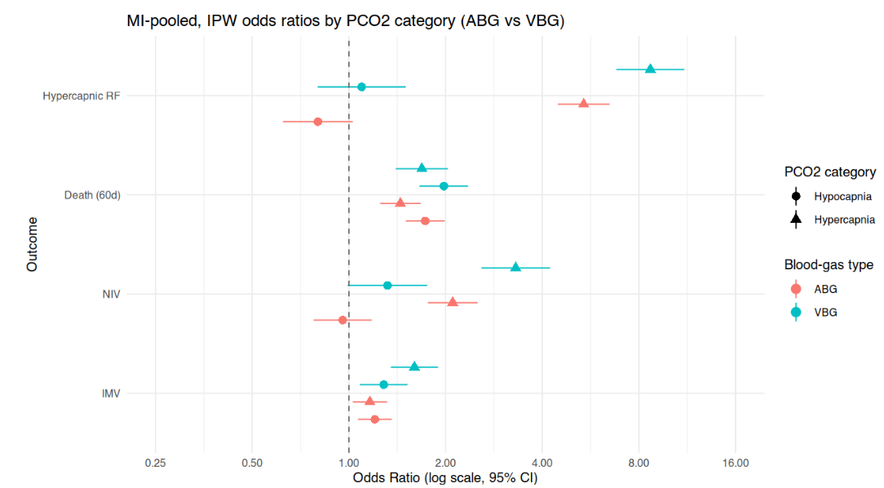

To further examine the continuous relationship between pCO₂ and clinical outcomes, restricted cubic spline models were constructed. Figure 3 presents the predicted probabilities for each outcome across pCO₂ values, stratified by ABG and VBG groups.

In Figure 3, there is a significant higher likelihood of receiving the four outcomes for the VBG group compared to ABG group as pCO₂ levels increase. Hypercapnic respiratory failure diagnosis and non-invasive ventilation had the largest gap in likelihood between the two groups. The predicted probability of the outcomes begin to increase at about 45 mmHg for ABG and 50 mmHg for VBG. Finally, mortality appeared unrelated to CO₂ status for the ABG group, suggesting that death in this cohort is more reflective of overall illness severity rather than hypercapnia itself.

Figure 3: Inverse Propensity Weighted Predicted Probability by ABG and VBG for the four outcomes. Across the four outcomes, ABG and VBG had similar likelihood of receiving the four outcomes. VBG had slightly higher likelihood in hypercapnic area for IMV, NIV and hypercapnic respiratory failure.
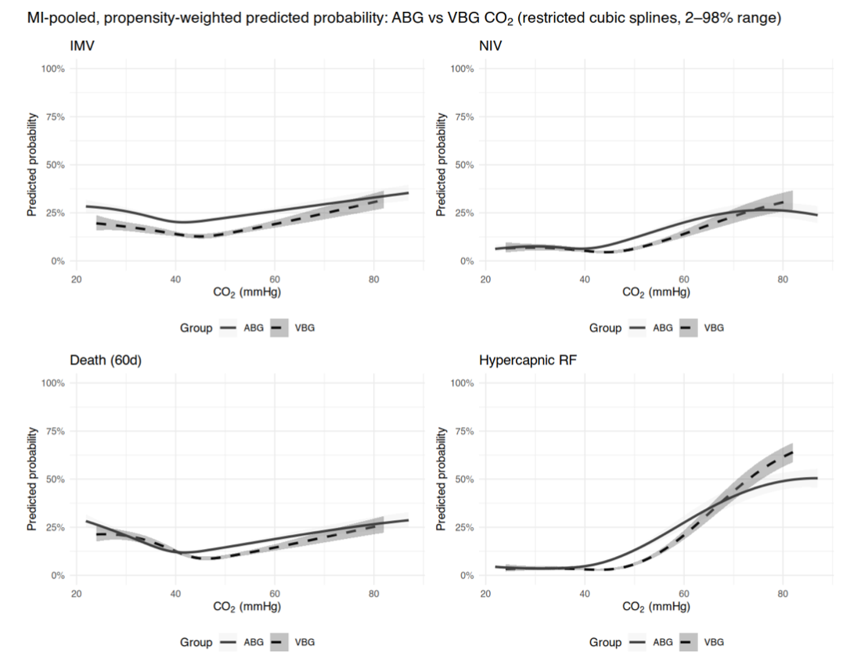

Discussion:

Overall, these findings suggest that venous and arterial blood gas measurements provide comparable clinical value in predicting key outcomes. The odds ratio for hypercapnia on ABG and VBG are 1.16 vs. 3.31 (IMV), 2.11 vs. 1.60 (NIV), 1.25 vs. 1.69 (mortality) and 5.39 vs 8.69 (diagnosis of hypercapnia respiratory failure). Venous hypercapnia retained robust prognostic associations across all outcomes, supporting its clinical relevance beyond analytic agreement.

Arterial hypercapnia had higher likelihood of NIV compared to VBG; however the remaining three outcomes, venous hypercapnia had higher likelihood compared to ABG. Evaluating the splines, IMV and mortality had somewhat flat predicted probability despite the CO2 value. This may be due to some patients receiving either blood gas have higher illness severity and may be intubated or expire due to another cause other than hypercapnic respiratory failure. Additionally, there was minimal difference in the odds ratios between the hypocapnia and hypercapnia groups for mortality in both blood gas groups. The NIV and hypercapnic respiratory failure splines, have an increase in predicted probability as CO2 reaches hypercapnia across both blood gas groups.

Previous studies have shown that venous and arterial pCO₂ values are strongly correlated. However, the prior work has focused on diagnostic accuracy or correlation coefficients rather than clinical outcomes. Our study evaluates whether hypercapnia identified on ABG or VBG is associated with subsequent clinical outcomes, not whether venous and arterial measurements are interchangeable or whether one sampling method causes difference outcomes. These prognostic inferences rest on the assumption that inverse propensity weighting adequately accounts for systematic differences in patients selected for ABG vs VBG testing. Although balance across measured covariates was achieved, residual confounding likely persists due to unmeasured factors such as clinician decision-making and availability of each test. These are examples of what may influence the decision to obtain and ABG vs VBG that is not captured fully within the electronic medical record.

Our results have broader implications for both clinical practice and healthy system policy. Despite widespread clinical use of VBGs to assess hypercapnia, formal diagnostic criteria, billing structures and device qualification requirements still rely on arterial confirmation. Aligning these frameworks with real-world practice could simplify workflows, reduce patient discomfort, and lower costs without comprising diagnostic accuracy. Expanding the acceptance of venous-based definitions may also enable more efficient outpatient follow-up and titration of non-invasive ventilation or supplemental oxygen therapy.

Strength and Limitations

This study has several strengths. Its large, multi-institutional cohort enhances analytic flexibility and minimizes overfitting risk, allowing stable modeling of sampling and outcome relationships. The study design reflects real-world clinical practice by stratifying patients who underwent either ABG or VBG testing, providing insight into how hypercapnia is assessed and managed across different clinical contexts. The use of multivariable logistic regressions and inverse propensity weighting allowed for the adjustment of measured cofounders and provided a robust assessment of associations between hypercapnia and important clinical outcomes such as mechanical ventilation, non-invasive ventilation and 60-day mortality. Propensity scores were estimated using a machine learning method that accommodates non-linear relationships and missing data. In addition, restricted cubic spline models were used to flexibly characterize the continuous relationship between pCO2 and outcomes without imposing linearity assumptions and multiple imputation was employed to address missing covariate data, reducing bias.

However, this study does have certain limitations. Model misspecification and missing data from the electronic medical records may suggest that using ABG and VBG are comparable in clinical outcomes but however in practice may not be accurate. Unmeasured variables such as clinican practice style or illness severity may have influenced both the likelihood of testing and clinical outcomes. Since data was extracted from the electronic health record, misclassification or missing data in comorbidities, test results or outcomes is possible. This study relied on single blood gas measurements obtained on hospital day 1, which limits the ability of assess temporal changes in pCO₂ or the effect of repeated sampling over time.

Further work is needed to confirm these findings in prospective studies. Pragmatic prospective cohort with protocolized testing comparing ABG versus VBG management could more directly establish causality and inform guidelines. Repeated measurements throughout a patient encounter as well would also better capture the relationship between changing pCO₂ values and outcomes. Studies incorporating post-discharge management and outcomes would clarify whether hypercapnia identified on VBG has implications beyond hospitalization. Additionally, subgroup analyses focusing on specific patient populations with certain comorbidities will further clarify whether VBGs are equally reliable as ABGs.

Conclusion:

In reweighted cohorts, VBG-identified hypercapnia showed similar prognostic associations to ABG for ventilatory support and mortality. VBG results were also similarly associated with subsequent diagnostic labeling, suggesting its use despite current formal criteria. This implies that broader acceptance of VBG-based definitions in billing and device qualification should be considered, pending external validation and associations with post-discharge management.

References:

1. Lacy ME, Saa L, Bruss Z, Noronha L. Things We Do for No ReasonTM: Arterial blood gas testing to screen for hypercarbic respiratory failure. J Hosp Med. 2025;20(9):1002-1004. doi:10.1002/jhm.70039
2. Davies MG, Wozniak DR, Quinnell TG, et al. Comparison of mathematically arterialised venous blood gas sampling with arterial, capillary, and venous sampling in adult patients with hypercapnic respiratory failure: a single-centre longitudinal cohort study. BMJ Open Respir Res. 2023;10(1):e001537. doi:10.1136/bmjresp-2022-001537
3. Ak A, Ogun CO, Bayir A, Kayis SA, Koylu R. Prediction of Arterial Blood Gas Values from Venous Blood Gas Values in Patients with Acute Exacerbation of Chronic Obstructive Pulmonary Disease. Tohoku J Exp Med. 2006;210(4):285-290. doi:10.1620/tjem.210.285
4. McKeever TM, Hearson G, Housley G, et al. Using venous blood gas analysis in the assessment of COPD exacerbations: a prospective cohort study. Thorax. 2016;71(3):210. doi:10.1136/thoraxjnl-2015-207573

Supplement:

Things like the propensity diagnostics could be included in the supplement.

Figure S1: Covariate Balance depicted below. Absolute Standardized Mean Differences were reduced to below 0.1, indicating adequate balance.

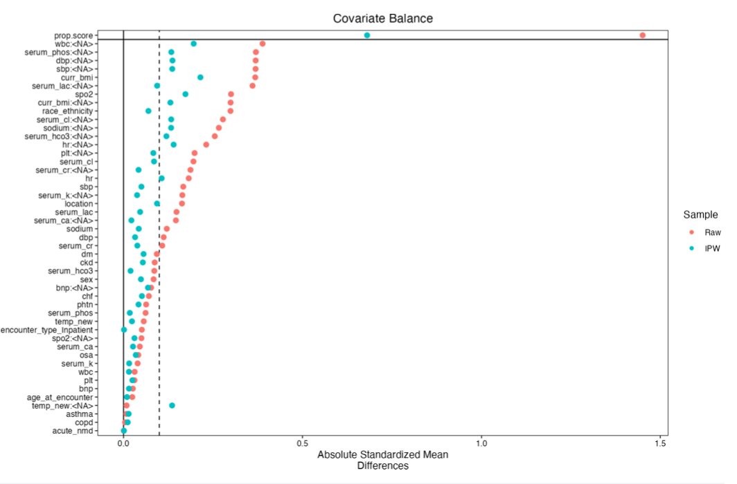

Figure S2: Distribution of Inverse Propensity-Weighted Scores for ABG and VBG groups. Untested patients clustered near zero, while tested patients were skewed toward higher probabilities of being tested.

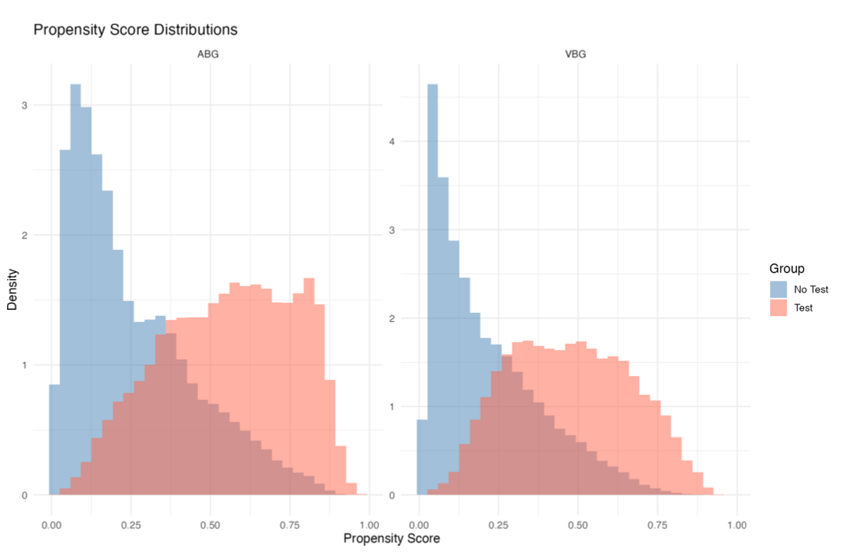

Figure S3: Global SHAP values for the ABG propensity model demonstrating that encounter type (emergency department vs inpatient) and location (region in the United States) were the dominant drivers of ABG selection.
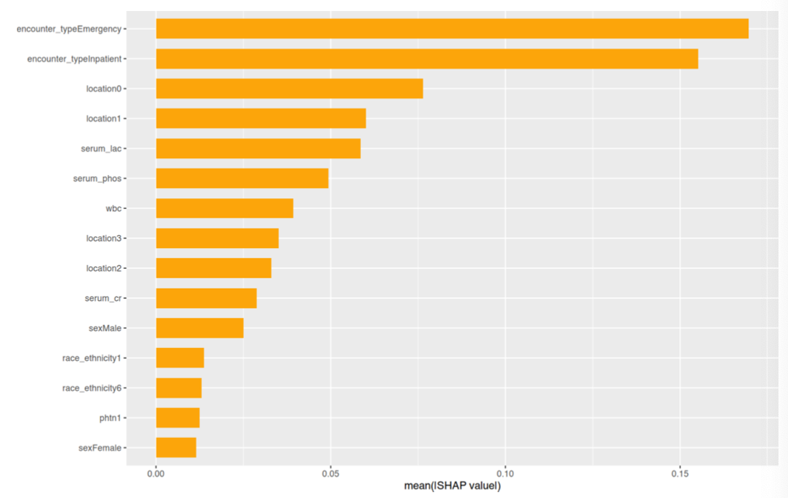

Figure S4: SHAP Dependence Plot for the key continuous predictor (encounter type: emergency department vs inpatient) in the ABG propensity model.

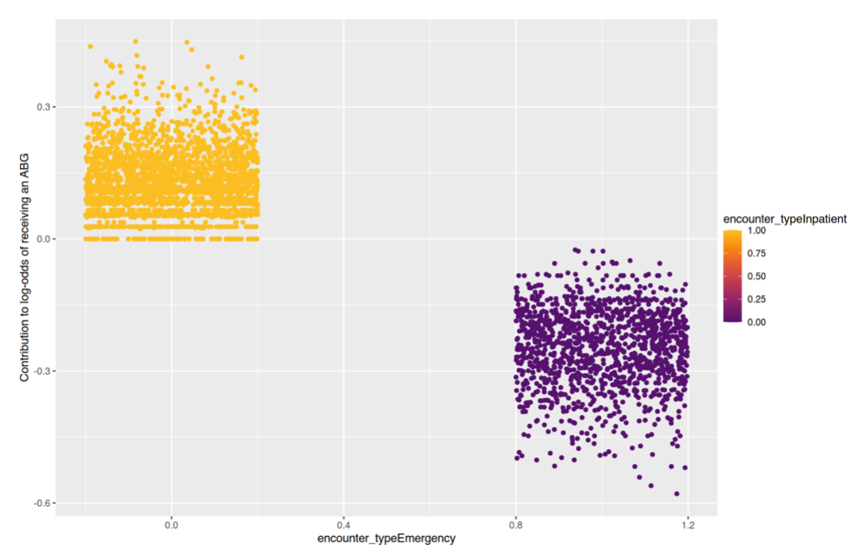

Figure S5: Global SHAP values for the VBG propensity model demonstrating that location (region in the United States) and race/ethnicity were the dominant drivers of VBG selection.

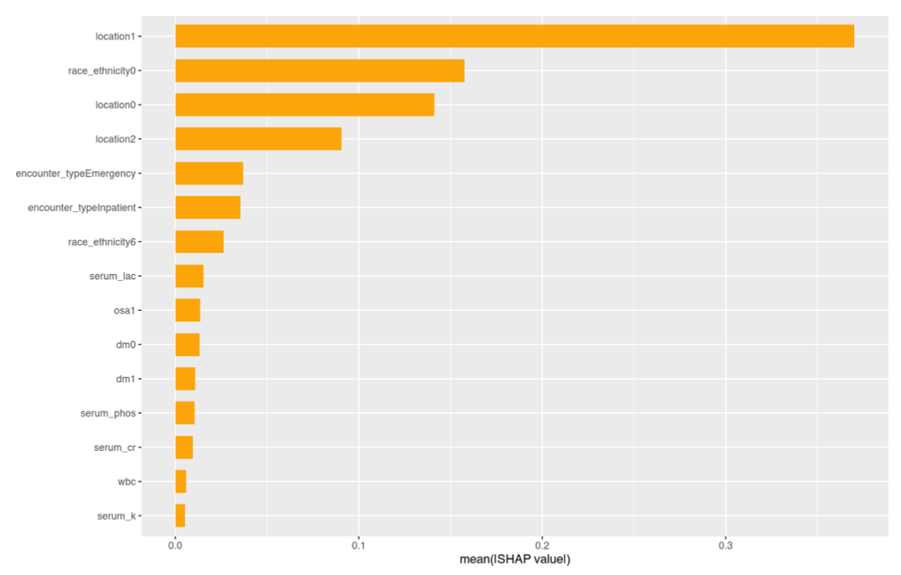

Figure S6: SHAP dependence plot for key continuous predictors (location and race/ethnicity) in the VBG propensity model.

